Standard Operating Procedure
Liquid Nitrogen

This is an SOP template and is not complete until: 1) Lab Specific information is entered into the box below 2) Lab Specific information is added to the various sections, 3) completed SOP has been approved by the PI, and 4) completed SOP has been signed and dated by all relevant lab personnel.

Keep a copy and in your lab safety shared folder or binder.

Department: | Click here to enter text.
SOP Preparation Date: | Click here to enter a date. | SOP Approval Date: | Click here to enter a date.
Principal Investigator: | Click here to enter text.
Lab Manager Name: | Click here to enter text.
Laboratory Phone: | Click here to enter text. | Office Phone: | Click here to enter text.
Emergency Contact: | Click here to enter text. | Contact Phone: | Click here to enter text.
Laboratory locations covered by this SOP (building / room number):
Click here to enter text.

Type of SOP: | ☐ | Process | ☒ | Hazardous Chemical | ☐ | Hazardous Class

Purpose

Liquid nitrogen is a cryogenic liquid that will likely cause severe frostbite or eye damage upon contact. It is an extremely cold liquid and gas under pressure, which expands by a factor of 700 upon vaporization and may cause an explosion of a sealed container. It can cause rapid suffocation due to displacement of oxygen. Substances may become brittle upon contact and shatter. It is typically used for tissue sample preservation, collection of gases, to help lower working pressures in lab vacuum systems, to control working reactions temperature, etc.

Physical and Chemical Properties / Definition of Chemical Group
CAS: | 7727-37-9 | 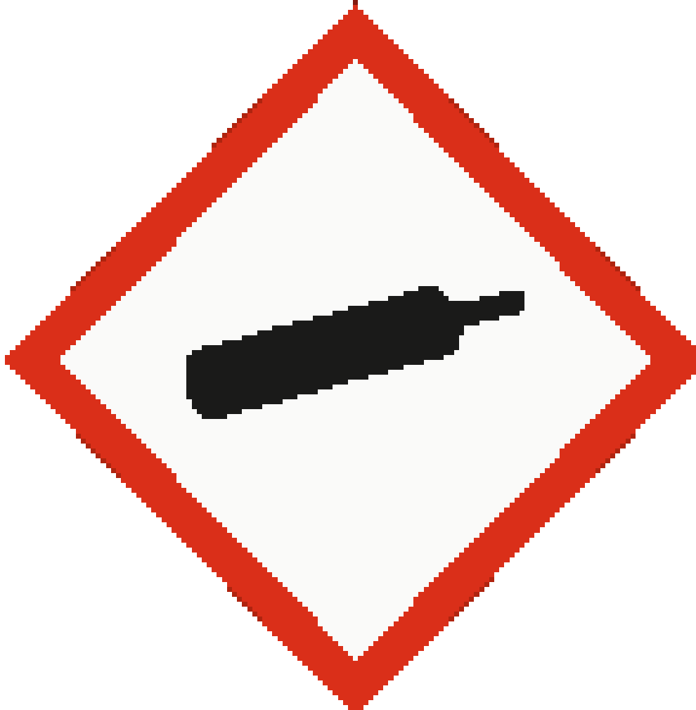
Class: | Gases under pressure - refrigerated liquefied gas
Molecular Formula: | N₂
Form (physical state): | Liquid (Cryogenic liquid)
Color: | Colorless
Boiling Point: | -195.8 °C

Potential Hazards / Toxicity
Hazards
- Super cold causing cryogenic burns and injury
- Expands rapidly at room temperatures – potential explosion hazard if not properly contained in a vented container.
- May displace oxygen and cause rapid suffocation
- Symptoms to exposure included frostbite, dizziness, salivation, nausea, vomiting, or loss of mobility and/or consciousness.
Potential Health Effects
Target Organs: | Exposed skin and body parts
Inhalation: | Adverse symptoms may include the following:, frostbite, dizziness, salvation, nausea, vomiting, loss of mobility and/or consciousness
Skin: | Adverse symptoms may include the following:, frostbite
Eyes: | Adverse symptoms may include the following:, frostbite
Ingestion: | Adverse symptoms may include the following:, frostbite

HIERARCHY OF CONTROLS:
Engineering Controls
Lab Specific Engineering Controls (Add your lab’s specific engineering controls in this section).
Click here to enter text.

Liquid nitrogen must only be used in a well-ventilated area or in a properly functioning chemical fume hood whenever possible. Liquid nitrogen should never be used in a poorly ventilated enclosed area where oxygen displacement is a possibility.

Administrative Controls
Lab Specific Administrative Controls (Add your lab’s specific administrative controls in this section).
Click here to enter text.

Adhere to the processes outlined in this SOP and the liquid nitrogen dispensing facility SOPs.

Personal Protective Equipment (PPE)
Lab Specific PPE requirements (Add your lab specific PPE requirements in this section).
Click here to enter text.

Hand Protection
Handle with thermally insulated gloves, such as cryogloves.
Note: Consult with your preferred glove manufacturer to ensure that the gloves you plan on using are compatible with liquid nitrogen.
Eye Protection
ANSI approved tight-fitting safety glasses/goggles. Face shields are required for filling dewars and handling quantities 100 mL and greater.

Skin & Body Protection

- Lab coat
- Full-length pants
- Closed-toed rubber or leather shoes
- Thermal gloves
- Face shields are required for filling dewars and handling quantities 100 mL and greater.

Respiratory Protection
Where risk assessment shows air-purifying respirators are appropriate, use a full-face respirator with multi-purpose combination (US) respirator cartridges.

Respirators should be used only under any of the following circumstances:
- As a last line of defense (i.e., after engineering and administrative controls have been exhausted).
- When Permissible Exposure Limit (PEL) has exceeded or when there is a possibility that PEL will be exceeded. Contact RMS to schedule air monitoring.
- Regulations require the use of a respirator.
- An employer requires the use of a respirator.
- There is potential for harmful exposure due to an atmospheric contaminant (in the absence of PEL).
- As PPE in the event of a chemical spill clean-up process.

Lab personnel intending to use/wear a respirator mask must be trained and fit-tested. This is a regulatory requirement.
https://riskmanagement.nd.edu/safety/occupational-health/respiratory-protection-plan/

Hygiene Measures

Avoid contact with skin, eyes, and clothing. Wash hands before breaks and immediately after handling the product.

Special Storage & Handling Requirements

Storage
- Store in a self-venting dewar designed for extreme cold. Note: Not all dewars are rated for liquid nitrogen or other cryogenics.
- Keep in a cool, dry, well-ventilated area away from incompatible materials and conditions.
- For cylinders, storage temperature is to not exceed 52°C (125°F).
- Cylinder contents under pressure and may explode when heated.

Handling
- Wear the PPE required in the PPE section above.
- Avoid contact with skin, eyes, clothing and inhalation as it can lead to frostbite.
- Prevent a build-up of pressure by using appropriate supplies and equipment.
- Note that cryotubes can catastrophically fail (explode) due to over-pressurization or damage to the tube. Be sure to inspect them for damage prior to use and monitor the tube’s temperature to mitigate this hazard.

Filling Dewars
- Adhere to your facility’s filling procedure.
- Wear PPE required above.

Transporting
- Dewars
  - Transporting Cryogens by Hand or Cart Through Hallways
    - Must be transported in a manner to ensure dewar does not tip or fall over.
    - Use a second person to help move larger dewars and liquid nitrogen refrigerators.
    - Ensure larger dewars and liquid nitrogen refrigerators are equipped with a braking mechanism.
    - Do not use your feet to “brake” wheels and take care to avoid crushing fingers and hands between the vessel and walls and door frames.
    - Be mindful of the vent valve as to not direct it towards people.
  - Transporting Cryogens on an Elevator
    - When a cryogens container has been placed on an elevator, the elevator must travel between floors unoccupied.
      - The confined space of the elevator and a leak in the cryogen container can quickly cause an oxygen deficient atmosphere by displacing the oxygen.
    - All elevator doors must be manned to prevent people from riding the elevator with the cryogens.
      - Someone must be stationed at all “in-between” floors to prevent riders from entering the elevator.
      - The sender should remain outside the elevator and activate it to the desired floor.
      - Another person should be available on the receiving floor to take the liquid container off the elevator at its destination.
    - If it is absolutely necessary to have an attendant in the elevator with the container, an escape pack supplemental breathing apparatus must be carried in the elevator.
- Cyrotubes
  - Must be overpacked in a sturdy container in a manner to prevent spills and exposure.
    - The overpack container must allow for venting to avoid over-pressurization.
    - An example would be to use a styrofoam box in a cardboard box, where the cardboard box is only tapes along the outer flap seam and the inner flap seams are left untaped.

EMERGENCY ACTION PLAN (EAP):
Lab Specific EAP (Add your lab’s specific emergency action plan variances in this section).
Click here to enter text.

First Aid Procedures

If inhaled… Remove victim to fresh air and keep at rest in a position comfortable for breathing. If not breathing, if breathing is irregular or if respiratory arrest occurs, provide artificial respiration or oxygen by trained personnel. It may be dangerous to the person providing aid to give mouth-to-mouth resuscitation. Get medical attention if adverse health effects persist or are severe. If unconscious, place in a recovery position and get medical attention immediately. Maintain an open airway. Loosen tight clothing such as a collar, tie, belt or waistband. In case of inhalation of decomposition products in a fire, symptoms may be delayed. The exposed person may need to be kept under medical surveillance for 48 hours. Call 911 from a campus phone or (574) 631-5555 from a cell phone to report exposure to Notre Dame Police Dept. (NDPD) dispatch.

In case of skin contact… Thaw skin with lukewarm water. Do not rub the affected area. Remove contaminated clothing and shoes and wash before reuse. Get immediate medical advice / attention. Call 911 from a campus phone or (574) 631-5555 from a cell phone to report exposure to Notre Dame Police Dept. (NDPD) dispatch.

In case of eye contact… Immediately flush eyes with plenty of water, occasionally lifting the upper and lower eyelids. Check for and remove any contact lenses. Continue to rinse for at least 10 minutes. Get medical attention if irritation occurs. Call 911 from a campus phone or (574) 631-5555 from a cell phone to report exposure to Notre Dame Police Dept. (NDPD) dispatch.

If swallowed… Remove victim to fresh air and keep at rest in a position comfortable for breathing. Get medical attention if adverse health effects persist or are severe. Ingestion of liquid can cause burns similar to frostbite. If frostbite occurs, get medical attention. Never give anything by mouth to an unconscious person. If unconscious, place in a recovery position and get medical attention immediately. Maintain an open airway. Loosen tight clothing such as a collar, tie, belt or waistband. As this product rapidly becomes a gas when released, refer to the inhalation section. Call 911 from a campus phone or (574) 631-5555 from a cell phone to report exposure to Notre Dame Police Dept. (NDPD) dispatch.

Spill and Accident Procedure

Personal precautions
Avoid breathing vapors, mist or gas. Ensure adequate ventilation. Evacuate personnel to safe areas. Do not attempt clean-up without minimum PPE.

Environmental precautions
Prevent further leakage or spillage – if safe to do so. Do not allow this product to enter drains.

Methods and materials for containment and clean-up
Consider oxygen displacement prior to clean-up. .

- Immediately assess the amount spilled, follow posted Lab Specific Emergency Action Plan procedures for hazardous materials incidents.
- If a chemical exposure has occurred, a fellow lab worker shall call 911 from a campus line or 574-631-5555 from a cell phone to report exposure to Notre Dame Police Dept. (NDPD) dispatch. Follow steps outlined in the EAP section above.
- Don compatible gloves and other protective PPE (see PPE section above) if not already being worn.
- Secure / restrict access to the area of the spill to prevent spread of the chemical.
- Use the available spill kit to stop and contain the spill.

Decontamination / Waste Disposal Procedure

Waste Labeling Requirements
- Label waste containers with the term “liquid nitrogen” and “extreme cold” (or cylinder GHS pictogram) to containers prior to the first drop of waste being added to the container.
Store waste
- Store in a fume hood or well ventilated area to allow sublimation and avoid oxygen displacement.
- Must be under the control of the person generating and disposing of it.

Dispose of waste
- Contact RMS at (574) 631-5037 for waste-related questions.

Protocol / Procedure

Lab Specific Procedures (Add your lab’s specific procedures in this section).
Click here to enter text.

IMPORTANT NOTE: Any deviation from this SOP requires advance PI approval.

Documentation of Training

- Prior to conducting any work with this material, Principal Investigator or designee must provide to his/her laboratory personnel specific to the hazards involved in working with this substance, work area decontamination, and emergency procedures.
- The Principal Investigator must provide his/her laboratory personnel with a copy of this SOP and a copy of the Safety Data Sheet (SDS) provided by the manufacturer available in MSDSOnline.
- The Principal Investigator must ensure that his/her laboratory personnel have attended appropriate/required laboratory safety training or refresher training within the last one year.

I have read, and understand, the content of this SOP and agree to abide by the requirements of this SOP.

Employee Name | Signature | Date

